GUIDEBEE
Map Tiled API Developer Guide
On Java ME platform



James Shen
www.guidebee.biz
Guidebee Biz.

ISSUE/AMENDMENT STATUS

Issue | Date | Description | Author
1.0 | 09th Mar 2008 | First Version | James Shen jing.shen@guidebee.biz

TABLE OF CONTENTS
ISSUE/AMENDMENT STATUS 2
1.0 Overview of Guidebee Map Server Java ME API 4
1.1 Package gis.geometry 4
1.2 Package gis.tiled 5
2.0 Map Basics 6
2.1 Sampe Map Tiles file 6
2.2 The "Hello, World" of TiledMap 6
2.2.1 Define the TiledMap Object. 8
2.2.2 Define MapTiledZone objects 8
2.2.3 Open the TileMap before call other methods. 8
2.2.4 Center the map on a given geographic point 9
2.2.5 Close the map after using 9
3.0 Map Operation 10
3.1 Zoom In/Zoom Out 10
3.2 Map Pan 12
4.0 Licence 15

- Overview of Guidebee Map Server Java ME API
Guidebee Map Tiled Java ME API manages map tiles stored locally. With Guidebee Map (Server) and Map (Local) API, application can create map image either from downloading map tiles from map server or from local geodatabase.
On mobile devices like phone, downloading map tiles or query from local geodatabase might be time-cosuming. To improvie map render performance, we can pre-download map tiles or pre-render vector map to raster map (map tiles) and store them locally. Guidebee Map Tiled Java ME API efficiently manange these map files.
Guidebee Map (Tiled) API used same methods as google/yahoo/Microsoft live map dividing the global map into map tiles.
Following is a table describes such division of map tiles of google map.
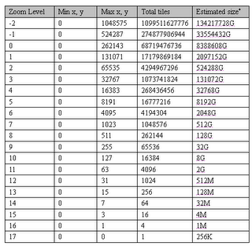
* Each tile is 256X256*4 = 256K, this is the maximum; normally a tile size is much less than 256K.
It includes following 2 sub packages:
- biz.guidebee.gis.geometry
- biz.guidebee.gis.tiled
  - Package gis.geometry
This package defines geographical geometry objects, like polygon, point, polyline etc.

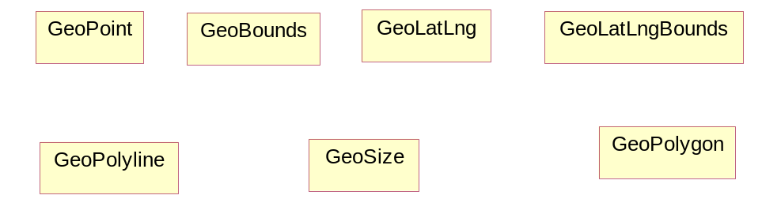
GeoBounds | GeoBounds is a rectangular area of the map in pixel coordinates
GeoLatLng | GeoLatLng is a point in geographical coordinate’s longitude and latitude.
GeoLatLngBounds | GeoLatLng is a bound in geographical coordinate’s longitude and latitude.
GeoPoint | A point representing a location in (x,y) coordinate space, specified in integer precision.
GeoPolygon | Polygon on map.
GeoPolyline | Polyline on map.
GeoSize | The GeoSize class encapsulates the width and height of a component (in integer precision) in a single object.
  - Package gis.tiled
The tiled package defines object used to query from GIS map tiles.
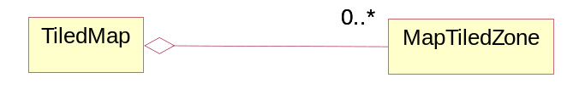
TiledMap | Define a tiled map.
MapTiledZone | Define a tiled map zone
MapTiledZone defines object manages stored map tiles in a specific geographical zones. The .map file stores all map tiles in PNG pictures and provides index to access these image map tiles.
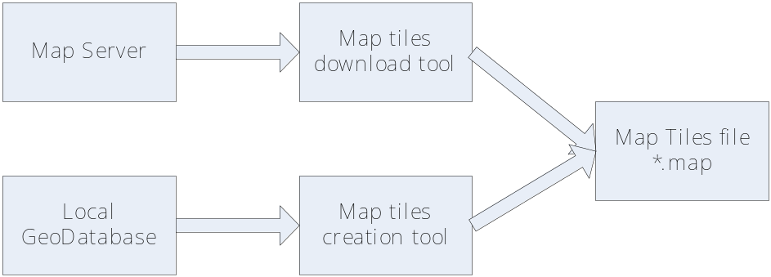
Map tiles file (*.map) which used by Guidebee Map (Tiled) API can be generated by two tools.
- Map Tiles download tool
Download map tiles from map server like yahoo, Microsoft Live map. This may can be only used for personal use in case it’s could violate the TOU of those company.
- Map Tiles creation tool
Read local geodatabase can render the vector map into map images and store it as .map file.

- Map Basics
The fundamental element in any Guidebee Maps (Tile) API application is the "TiledMap" itself. Actually the usage of TiledMap is quite similar to SeverMap, the only major difference is TiledMap ‘download’ map locally (stored in the .map file) instead of download from Map Server.another problem is normally TileMap doesn’t provide any Map Service (like geocoding, find address). So the most offen used use case it works together either with LocalMap or ServerMap to provide a whole mobile GIS solution.
  - Sampe Map Tiles file
Examples use some sample map tile files.
World05.map google map tiles of the whold world from zoom 0 to 5. Stores 1365 tiles.
World6.map google map tiles of the whold world of zoom 6. Stores 4096 tiles.
World7.map google map tiles of the whold world of zoom 7. Stores 16484 tiles.
Note: Guidebee Map API uses zoom level with the minimum 0 and maximum 17 (some time 20). 0 is the lowest zoom Level.
  - The "Hello, World" of TiledMap
The following example displays a map center at Perth, Australia.

//--------------------------------- PACKAGE ------------------------------------
package biz.guidebee.gis.tiled.example;

//--------------------------------- IMPORTS ------------------------------------
import javax.microedition.midlet.*;
import javax.microedition.lcdui.*;

import biz.guidebee.gis.tiled.*;
import biz.guidebee.gis.geometry.*;

class MapCanvas extends Canvas{
TiledMap map=null;
MapCanvas(){

}

public void setTiledMap(TiledMap map){
this.map=map;
}
protected void drawMapImage(Graphics g){
Image image=map.getMapImage();
g.drawImage(image,0,0,Graphics.TOP|Graphics.LEFT);
}

protected void paint(Graphics g){
drawMapImage(g);
}
}

public class HelloWorld extends MIDlet{

/**
* The display object associated with the MIDlet.
*/
private Display display;

/**
* The Canvas object.
*/
private MapCanvas canvas;

private TiledMap map;

public HelloWorld() {
display = Display.getDisplay(this);
canvas = new MapCanvas();
map=new TiledMap(canvas.getWidth(),canvas.getHeight());

try{
String mapFile="file:///map/world05.map";
MapTiledZone mapTiledZone=new MapTiledZone(mapFile);
map.addZone(mapTiledZone);
map.open();
canvas.setTiledMap(map);
}catch(Exception e){

}

}

public void startApp() throws MIDletStateChangeException {
display.setCurrent(canvas);
GeoLatLng center=new GeoLatLng(-31.948275,115.857562);
map.setCenter(center,5);
canvas.repaint();
}

public void pauseApp(){

}

public void destroyApp(boolean unconditional)
throws MIDletStateChangeException {

}

}

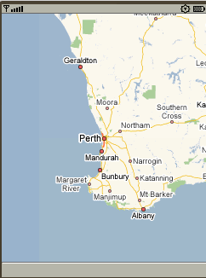
Even in this simple example, there are several things to note:
- Define a TiledMap instance to create a new “Map” object.
- Define MapTiledZone objects to manange map tiles within geographical zones. And add those map tile zones to TileMap instance.
- Open the TileMap before call other methods.
- Center the map on a given geographic point.
- Close the map after using.
These steps are explained below.
    - Define the TiledMap Object.
TiledMap’s constructor is defined as following:
public TiledMap(int width,
int height)
width and height defines the width and height of the map ,normally it’s the width and height of the canvas.
    - Define MapTiledZone objects
MapTiledZone defines object manages stored map tiles in a specific geographical zones.
TileMap manages a collection of MapTiledZone objects. When query for a specific region, TileMap go through the collection the MapTiledZones and find which zone contains such map tiles and return to the caller.
MapTiledZone mapTiledZone=new MapTiledZone(mapFile);
map.addZone(mapTiledZone);
    - Open the TileMap before call other methods.
Map need to be opened before using it. The open methods actually opens the reader input stream. The input Stream has to support mark() methods. For Guidebee (Tiled) Map requires random access to the map file to obtain a good performance.
map.open();
    - Center the map on a given geographic point
The following code center the map at Perth with zoom level equals 5.
GeoLatLng center=new GeoLatLng(-31.948275,115.857562);
map.setCenter(center,5);
    - Close the map after using
Generally speaking, after using the TileMap, method close() shall be called upon the TileMap instance to close any opened input stream.

- Map Operation
TiledMap has methods to zoom/pan the map.
  - Zoom In/Zoom Out
The following examples display how to zoom in/Zoom out map.

//--------------------------------- PACKAGE ------------------------------------
package biz.guidebee.gis.tiled.example;

//--------------------------------- IMPORTS ------------------------------------
import javax.microedition.midlet.*;
import javax.microedition.lcdui.*;

import biz.guidebee.gis.tiled.*;
import biz.guidebee.gis.geometry.*;

class MapZoomCanvas extends Canvas implements CommandListener{
TiledMap map=null;
private Command cmdZoomIn=new Command("ZoomIn",Command.ITEM,1);
private Command cmdZoomOut=new Command("ZoomOut",Command.ITEM,1);
MapZoomCanvas(){
addCommand(cmdZoomIn);
addCommand(cmdZoomOut);
setCommandListener(this);
}

public void setTiledMap(TiledMap map){
this.map=map;
}
protected void drawMapImage(Graphics g){
Image image=map.getMapImage();
g.drawImage(image,0,0,Graphics.TOP|Graphics.LEFT);
}

protected void paint(Graphics g){
drawMapImage(g);
}

public void commandAction(Command command, Displayable displayable) {
// for Tool command
if (command == cmdZoomIn) {
map.zoomIn();
repaint();
}
if (command == cmdZoomOut) {
map.zoomOut();
repaint();
}
}
}

public class MapZoom extends MIDlet{

/**
* The display object associated with the MIDlet.
*/
private Display display;

/**
* The Canvas object.
*/
private MapZoomCanvas canvas;

private TiledMap map;

public MapZoom() {
display = Display.getDisplay(this);
canvas = new MapZoomCanvas();
map=new TiledMap(canvas.getWidth(),canvas.getHeight());

try{
String mapFile="file:///map/world05.map";
MapTiledZone mapTiledZone=new MapTiledZone(mapFile);
map.addZone(mapTiledZone);
mapFile="file:///map/world6.map";
mapTiledZone=new MapTiledZone(mapFile);
map.addZone(mapTiledZone);
mapFile="file:///map/world7.map";
mapTiledZone=new MapTiledZone(mapFile);
map.addZone(mapTiledZone);
map.open();
canvas.setTiledMap(map);
}catch(Exception e){

}

}

public void startApp() throws MIDletStateChangeException {
display.setCurrent(canvas);
GeoLatLng center=new GeoLatLng(-31.948275,115.857562);
map.setCenter(center,5);
canvas.repaint();
}

public void pauseApp(){

}

public void destroyApp(boolean unconditional)
throws MIDletStateChangeException {

}

}

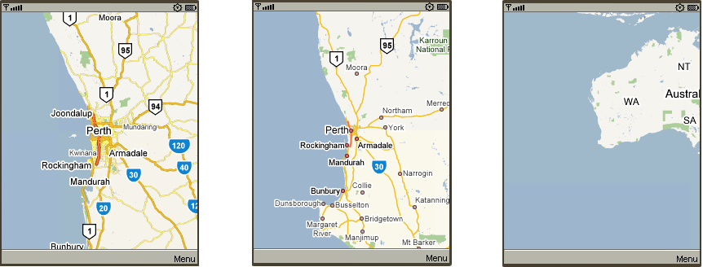
  - Map Pan
TiledMap has two pan methonds, panDirection and panTo. panTo pan the current pan to a given latitude,longtitude, panDirection move the map to some distance relative to current position.
The following example how to pan the map in up,down,left,right directions.

package biz.guidebee.gis.tiled.example;

//--------------------------------- IMPORTS ------------------------------------
import javax.microedition.midlet.*;
import javax.microedition.lcdui.*;

import biz.guidebee.gis.tiled.*;
import biz.guidebee.gis.geometry.*;

class MapPanCanvas extends Canvas implements CommandListener{
TiledMap map=null;
private Command cmdUp=new Command("Up",Command.ITEM,1);
private Command cmdDown=new Command("Down",Command.ITEM,1);
private Command cmdLeft=new Command("Left",Command.ITEM,1);
private Command cmdRight=new Command("Right",Command.ITEM,1);
MapPanCanvas(){
addCommand(cmdUp);
addCommand(cmdDown);
addCommand(cmdLeft);
addCommand(cmdRight);
setCommandListener(this);

}

public void setTiledMap(TiledMap map){
this.map=map;
}
protected void drawMapImage(Graphics g){
Image image=map.getMapImage();
g.drawImage(image,0,0,Graphics.TOP|Graphics.LEFT);
}

protected void paint(Graphics g){
drawMapImage(g);
}

public void commandAction(Command command, Displayable displayable) {
// for Tool command
if (command == cmdUp) {
map.panDirection(0,-32);
repaint();
}
if (command == cmdDown) {
map.panDirection(0,32);
repaint();
}
if (command == cmdLeft) {
map.panDirection(-32,0);
repaint();
}
if (command == cmdRight) {
map.panDirection(32,0);
repaint();
}
}
}

public class MapPan extends MIDlet{

/**
* The display object associated with the MIDlet.
*/
private Display display;

/**
* The Canvas object.
*/
private MapPanCanvas canvas;

private TiledMap map;

public MapPan() {
display = Display.getDisplay(this);
canvas = new MapPanCanvas();
map=new TiledMap(canvas.getWidth(),canvas.getHeight());

try{
String mapFile="file:///map/world05.map";
MapTiledZone mapTiledZone=new MapTiledZone(mapFile);
map.addZone(mapTiledZone);
map.addZone(mapTiledZone);
map.open();
canvas.setTiledMap(map);
}catch(Exception e){

}

}

public void startApp() throws MIDletStateChangeException {
display.setCurrent(canvas);
GeoLatLng center=new GeoLatLng(-31.948275,115.857562);
map.setCenter(center,5);
canvas.repaint();
}

public void pauseApp(){

}

public void destroyApp(boolean unconditional)
throws MIDletStateChangeException {

}

}

- Licence
Guidebee Map (Tiled) API provides classes to access map services from Yahoo, Microsoft etc. before using their map service, please read their User Agreement. Your violation of their TOU is at your own risk.
Guidebee Map (Tiled) API itself is free to use.

